Finley High School
Newsletter
Principal: Mrs H McRae Deputy Principal: Mrs P Jackson

19th May 2016
KEY DATES

May
20 Harmony Day
23 Defence Force Visit
24 – 26 CHS Netball
26 Future Moves Campus visit
30 - 31 Year Ten Work Experience

June
1 – 3 Year Ten Work Experience
3 Zone Athletics in Deniliquin
10 HSC Mid-Course Exam
13 Queen’s Birthday
14 – 15 HSC Mid-Course Exams
15 – 17 Holbrook Sheep and Wool Show
17 Riverina Cross Country

Principal’s Report
Last week was an absolutely fabulous week for all students and staff at Finley High School. Between the outstanding success of the MADDD night and the wonderful participation and attendance at the Athletics Carnival, the spirits of the school were well and truly soaring. I congratulate all staff and students on the committed way they approached these two events and worked together to bring laughter to all our faces.
MADDD Night
MADDD night was held last Wednesday evening and showcased the talents of students from every year group. It was a true team effort.
The students who appeared on stage were energetic and enthusiastic, not to mention extremely talented. They wrote the skits, rehearsed the songs, developed the costumes and supported each other throughout.

Behind the scenes the backstage crew ensured the show ran smoothly; music, lights, sets and technology all required considered planning and excellent execution.
The Hospitality team, parents and students who provided a delicious supper served by courteous and happy volunteers and the parents and friends who helped stack the chairs at the end of the evening made this night a very memorable whole school community evening.
We can all be proud of the students, staff and parents who were involved it allowed Finley High School to showcase the depth of its creative talent and community spirit.
Athletics Carnival
Last Friday saw another fantastic event at the school. The annual Athletics Carnival was held in beautiful sunshine at the Finley Recreation Reserve.
Student attendance was up this year as was student participation. The energy and enthusiasm students displayed was impressive.
Eighteen records were broken on the day. This is an amazing achievement for one carnival.
Staff whipped the students in the staff versus Year Twelve relay and we are all looking forward to the annual staff versus Year Twelve soccer match this Friday.

This year saw the inaugural Finley High School Gift – a race of the fastest 100m runners in the school. The fastest boy in the school was Nick Baldwin (Year Ten) and the fastest girl was Kayla Smith (Year Eight). These races finished a fantastic carnival.
I would like to thank Miss Downey for her organisation of the event with the support of the PE staff, Mr O’Hora, the Canteen staff and volunteers, the parents who came to watch and help and the teachers who manned their posts all day. At the end of the day, the oval was left spotless. Not a piece of rubbish in sight. Well done to all the students who participated in such an enthusiastic and responsible way, while having lots of fun!
Coree was the winning house on the day.
Mrs Littlejohn
Last week, Mrs Littlejohn volunteered her time to attend the Riverina Beginning Teachers Conference in Narrandera to present a workshop on how she uses technology in the classroom. It is wonderful to see teachers from Finley High School stepping up to showcase their talents and skills as excellent teachers.
Our new Director, Public Schools, Mr Troy Mott was very impressed and shared this in his annual bulletin to Principals across the Deniliquin network:
“At the beginning teacher conference Kate Richardson, a History teacher from Finley High School, was a highlight. She demonstrated how she uses Google Apps to engage the interest of her students in every year. Her use of technology to develop an “exit pass” at the end of her lessons was incredible.”
Congratulations, Kate!
Many Thanks to Finley Second Hand Shop
Last week, we were very fortunate to receive a donation of $2 000 from the Finley Community Second Hand Shop. This very generous donation has been given to assist students with excursion expenses so that all students may participate in all learning opportunities the school has to offer.
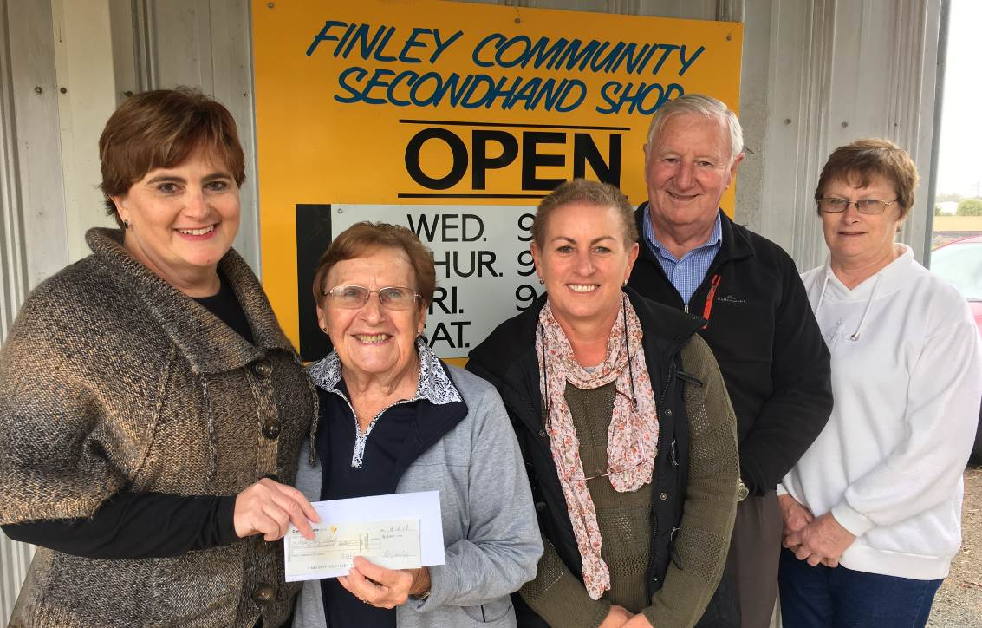
The spirit of support of our local community members is heart-warming and we thank the volunteers at the Finley Community Second Hand Shop for their generosity.

Left: Members of the Finley Community Secondhand Shop presenting a cheque to Mrs Helen McRae.
Foyer
In our efforts to encourage all students to strive for personal success, we have reorganised the foyer to reflect the outstanding achievements of our students.
We have moved our new trophy cabinets to the foyer to display the awards awaiting those students who strive to succeed at school. Our top students and their Band 6 results from the 2015 HSC are on display as well as the MADDD night team, photos of our swimming champions and photos of our 2016 Timor Leste group of students.
We are also displaying our ribbons and trophies from the Royal Sydney, Melbourne and Canberra Shows.
I would invite all parents and community members to come into the foyer and have a look and appreciate the history of success at Finley High School which is ongoing in 2016.
Flying Boomerangs for Jai Taylor
We extend huge congratulations to Jai Taylor who has been selected in the AFL Flying Boomerangs Leadership Program. This selection not only recognises Jai’s outstanding football ability but also his leadership potential.
The Flying Boomerangs is seen as a leading pathway program into the AFL system and is designed to accelerate a player’s potential through the cultural and personal development activities undertaken in the program throughout the year.
Jai will spend the next school holidays on the Gold Coast playing football in preparation for the ultimate trip to China in November.
Jai and his family can be very proud of his achieving a place in this team and we wish him every success.
Study Skills
I would like to remind all students and parents that we subscribe to www.studyskillshandbook.com.au. This website is full of study tips and techniques to assist students to optimise their learning at school. The username is finleyhs and the password is 54success. I encourage everyone to have a look at the website and learn how best to learn!
Homework Centre
I also remind all parents and students that the Homework Centre operates in the library after school each Wednesday. Over 100 students have taken advantage of the centre to complete homework and assignments with teachers help over the past term.
Afternoon snacks are provided so that students won’t be hungry as they learn in a warm and relaxed environment. Many teachers and support staff have volunteered their time to helps students out at the centre. I encourage all students to take advantage of the Homework Centre during the term.
NAPLAN
Last week saw Year 7 and Year 9 students complete their NAPLAN assessments for 2016. I was pleased to see that students took the exams seriously and tried their best. We do remember though, that school is about more than this one week of testing. Students who come to school learn so much more than the 3Rs. The positive, happy and friendly students we have at school, who actively participate in a wide range of activities, are developing skills and mindsets that are creating responsible young citizens of the future who are challenged to achieve their dreams.
While NAPLAN results will be released in Term 3, we must always focus on the education of the whole person who we are lucky enough to have as our children and students, not merely a test result!
KRAM Winners
We had a double KRAM draw on Tuesday’s Assembly. Congratulations to the following winners:
I-Tunes Vouchers: Ruana McGrath, Jake Sartore, Tamara Podesta, Jeremy Gastin, Isabel Alexander and Jacinta Curry
Canteen Vouchers: Will Sexton, Max Cameron, Justin Lawton and Sam Stokes
Handballs: Maddie Haintz, Alysha Knight, Logan Shumack-Bell and Blake Barry
Mrs Helen McRae
Principal

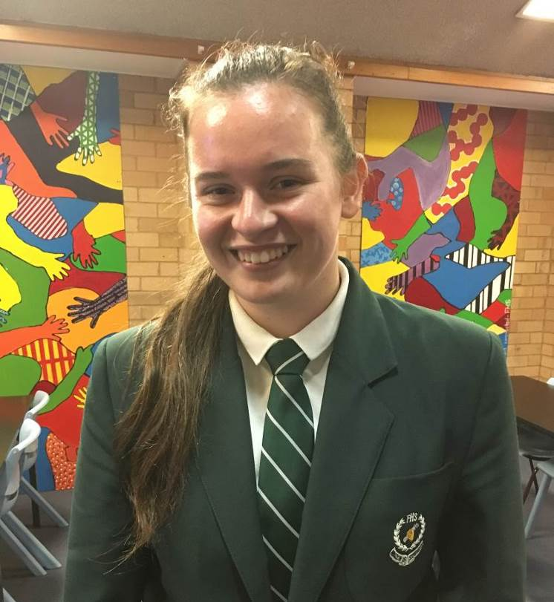
Sydney Morning Herald Public Speaking Competition
Chelsea Dempster won the regional final of the Sydney Morning Herald Public Speaking competition. She participated via video conference as it was hosted in Batlow this year. Chelsea's 8 minute prepared speech was titled 'The Epidemic' and dealt with homelessness. Her 3 minute impromptu was on the right to vote. The adjudicator commented that Chelsea's impromptu was as well structured and as well presented as her prepared speech.
Congratulations to Chelsea who will participate in the state semi-final in Sydney in the near future.
Co-ordinator
Mrs V McNaught

Inter-school Chess Competition
Congratulations to the Finley High School chess team, who had a great home win on Monday. The team comprising of Warren Pitt, Michael Henshaw and Shirsho Roy, along with Grant-Patrick Smith, who stood in for Sabrina Taylor out sick, played Barham High School in the second round of the competition run by the NSW Junior Chess League.
All 4 boys played really well, resulting in a 4 – 0 victory. Grant-Patrick stunned everyone by defeating his opponent in less than 30 seconds, finishing before some of the other games had even started.
The team will now wait to find out who they will play in the next round.
Ms A Begbie (chess coordinator)
Tertiary Tour
In week 2 this term Year Twelve students undertook the Melbourne Tertiary Tour visiting various Universities and TAFE’s around Melbourne and the AGE VCE Careers EXPO. Covering a large distance on foot, the students managed to see and experience a range of different institutions. They visited La Trobe Bundoora where they spent time mixing with the local students in the plaza of the university. They had some morning tea and did a little self exploration before heading off on a tour of the campus and accommodation. They then headed into the city to Melbourne Parkville Campus and College Crescent where they enjoyed a lovely hot lunch at University College. They toured the facilities before meeting up with ex-student Chloe O’Bryan for a tour around the prestigious Ormond College. Then it was off around Melbourne University to see the beauty and bustle of the inner city campus. One final stop on Day 1 saw them complete the race around the campus at RMIT City before they headed out for the evening.
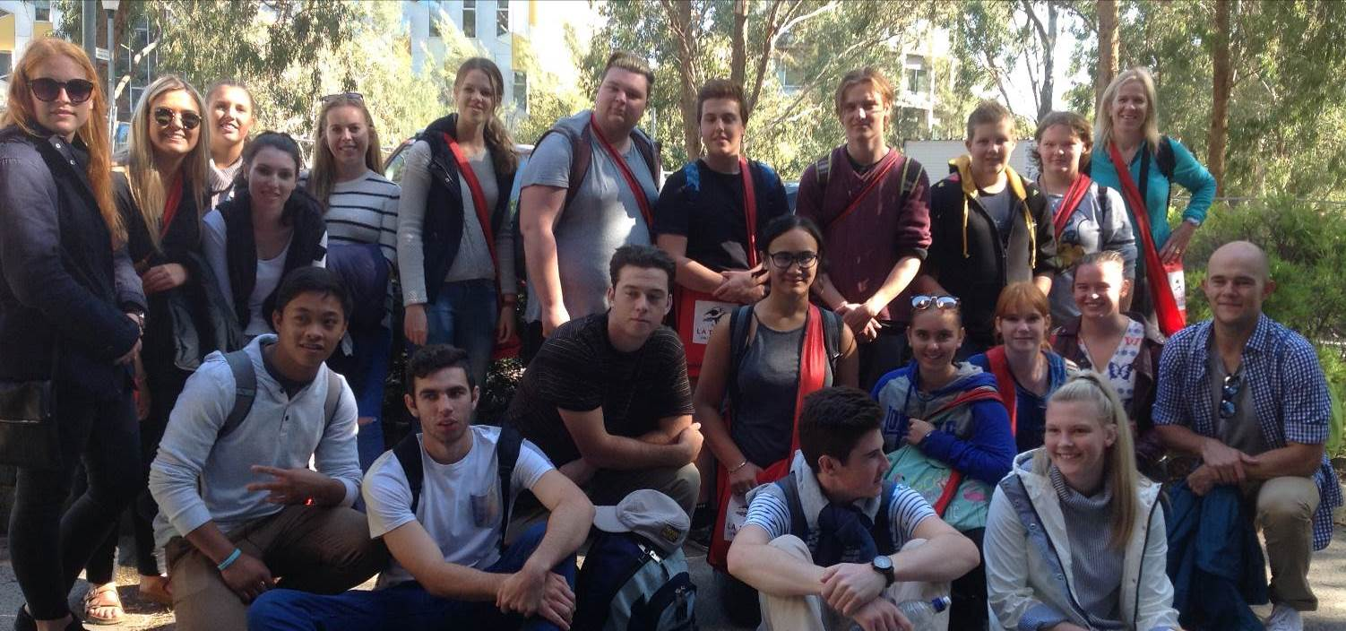
Above: La Trobe University Accommodation Tour
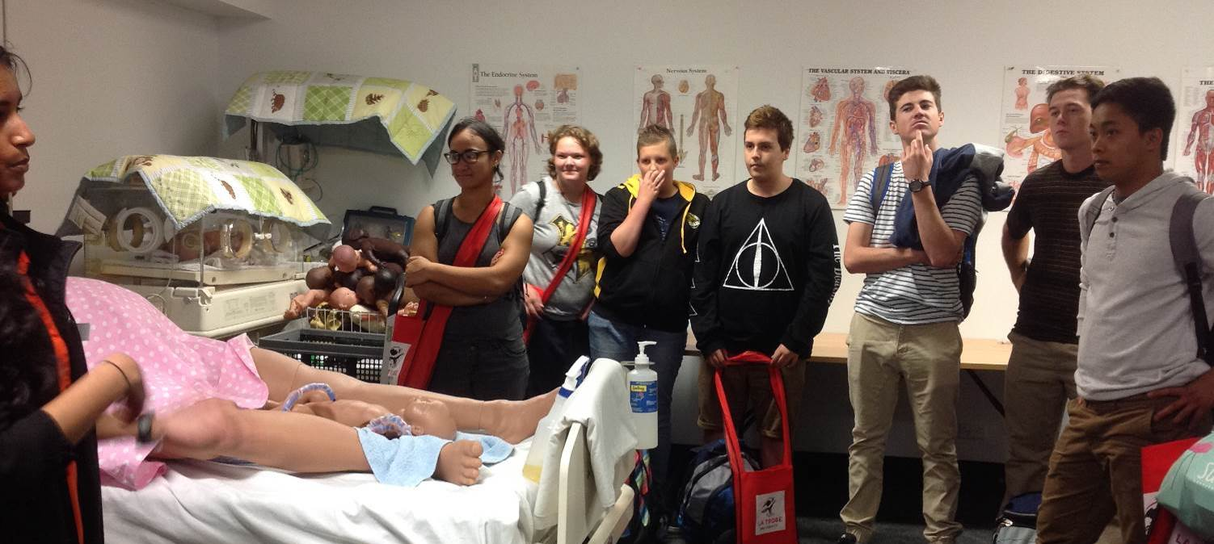
Above: La Trobe University Tour of Nursing midwifery facilities.

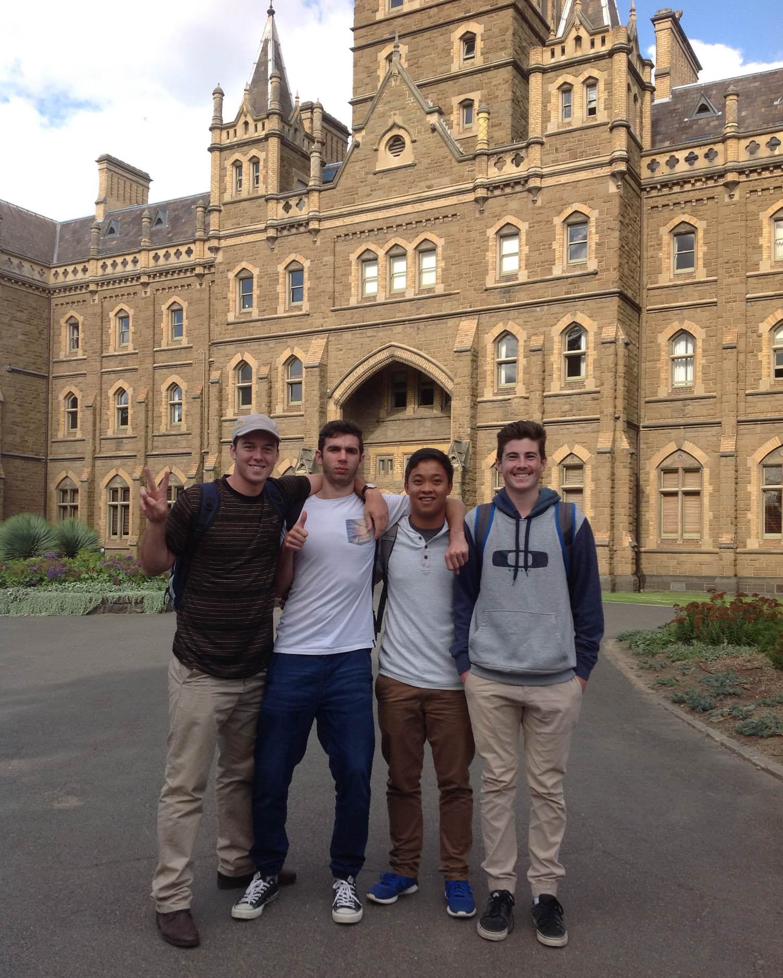Above: Grant-Patrick Smith, Samuel Orro, Lanz De Peralta and Callum Robertson at Ormond College
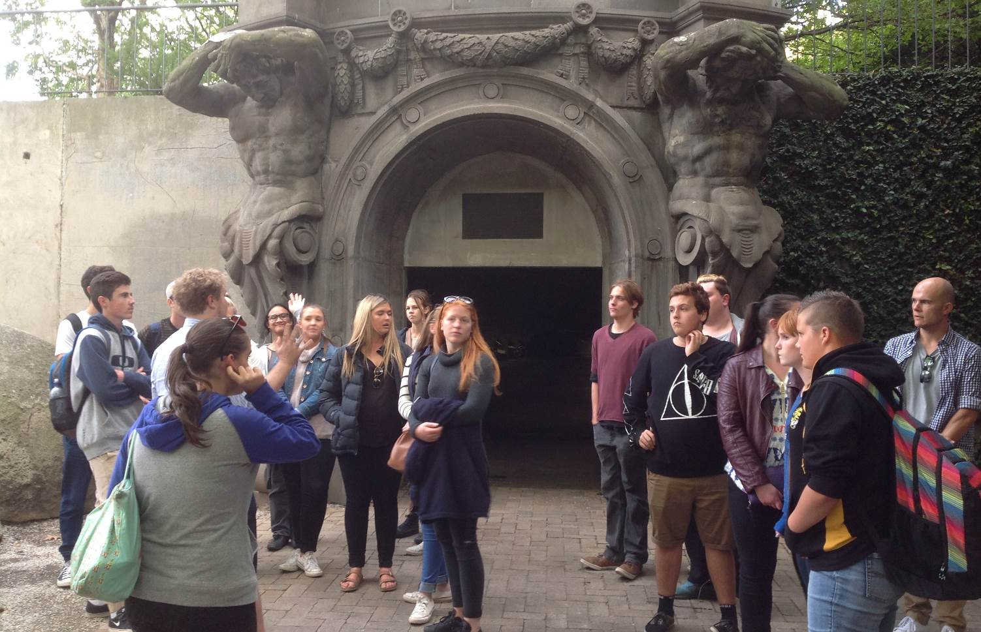
Above: Students on the Melbourne University Campus Tour.
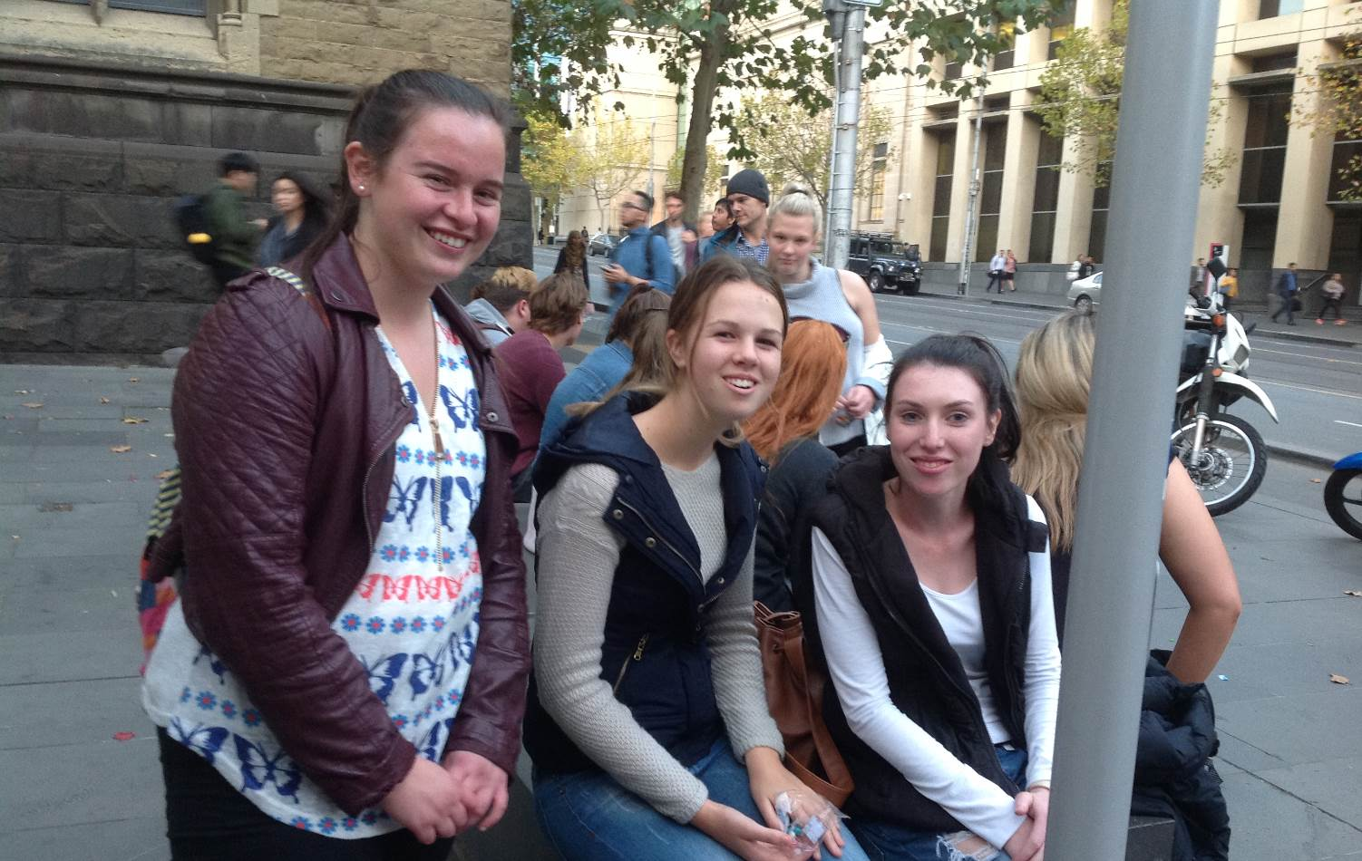
Above: RMIT City Race around the campus Chelsea Dempster, Abby Taylor and Zoe McCaw.
On day 2 an early start saw the students take in the Vic Markets for a spot of Mother’s day shopping, a hot jam donut or two and a steaming coffee to keep them going. They then came face to face with the crowds at the AGE VCE Careers EXPO at Caulfield where they took the opportunity to speak with a multitude of presenters and recruiters from an array of tertiary providers. A fresh look at TAFE was then provided as they toured Holmesglen TAFE where a large number of the trades are clearly on display. Students walked the glass covered walkways and viewed apprentices hard at work in the rooms below. A final stop at Monash Clayton saw us meet up with ex-student Michael McRae for a talk about his university experiences. A final presentation and tour of the facilities including the new designer accommodation and lush sporting grounds saw students wearily hopping on the bus to head home. The students behaviour was fantastic over the 2 days with a number of presenters and personnel commenting on this. We hope that the tour has provided some food for thought and given them an insight into some of the possible options for next year.

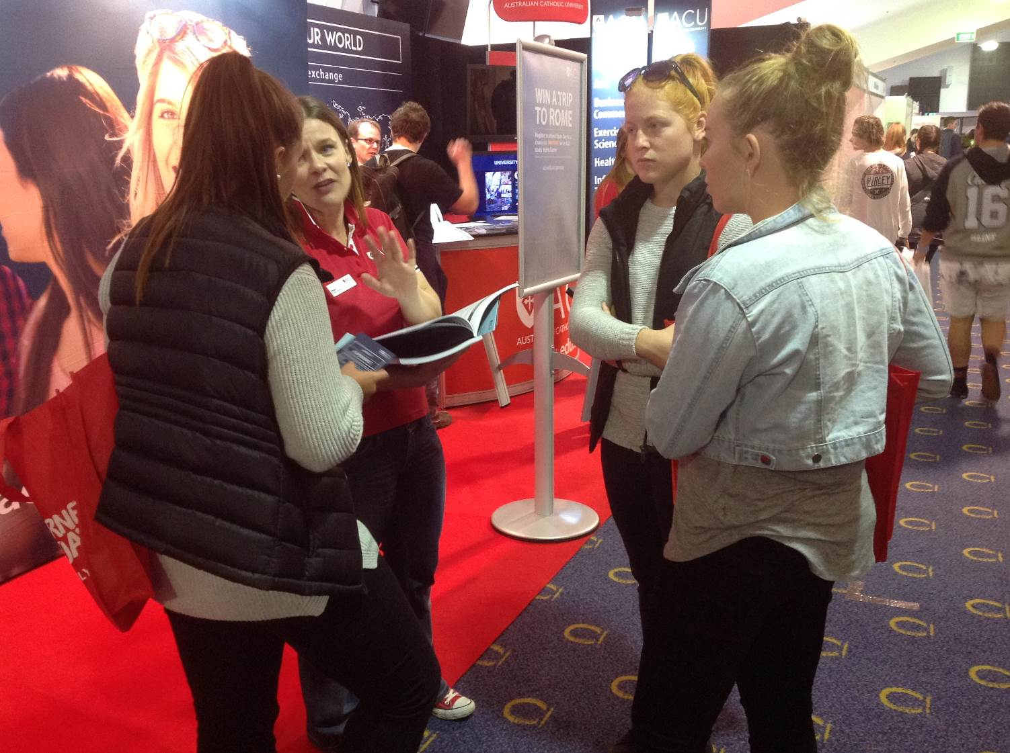
Above: AGE VCE EXPO information gathering. Maddison Haintz, Leah Dalgliesh and Alysha Knight.
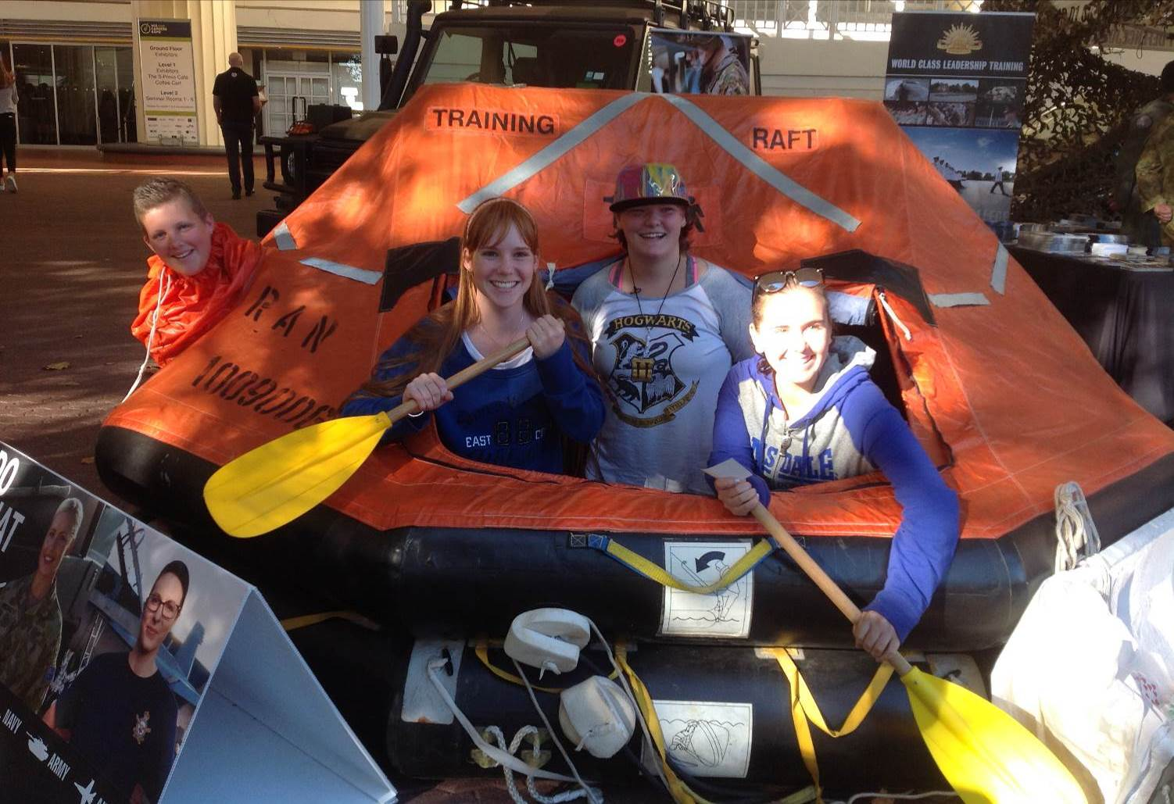
Above: AGE VCE EXPO Defence Forces. Kylie Wooden, Shania MacCullagh, Natalie Pitt and Caitlin Pettit.
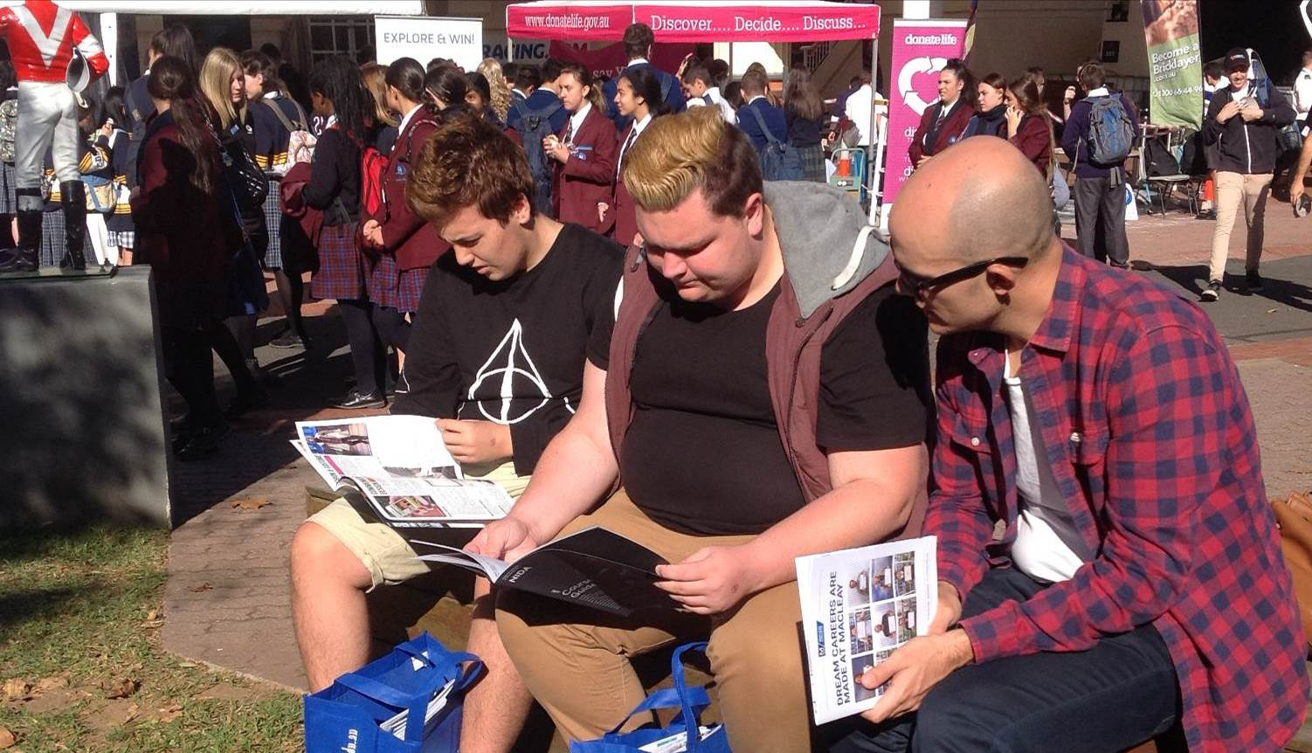Above: Joshua Barrett, Tyson Peters and Mr Davis at VCE AGE Careers EXPO
Athletics Carnival
Friday the 13th saw many students attend the annual athletics carnival. It was a beautiful day, which may have helped contribute to 19 records being broken. These were:
Ben Ashley-Cooper: 400m, Javelin and Triple Jump
Nicholas Baldwin: 100m
Tyrone Smithers: Triple Jump
Sam Orro: Long Jump
Ally Barlow: 200m and 400m
Tiarna Burke: 200m, High Jump and Triple Jump
Jemma Coombs: 400m and 1500m
Sascha Jones: Long Jump
Dora Miaoudis: Discus
Kayla Smith: 100m, 200m, 400m and Long Jump
Another highlight of the day was the teacher versus Year Twelve relay race. I am pleased to say that on this occasion the teachers were victorious. I am sure that the Year Twelve students are keen to get a win in the soccer game that will happen this Friday for Harmony Day.
This carnival we saw the inaugural running of what is to be a very prestigious event: ‘Fastest Boy’ and ‘Fastest Girl’ in the school. Entry was granted by winning the 100m in an age group, with each student competing against each other in one final 100m dash. I am proud to announce the winners of this event as Nicholas Baldwin and Kayla Smith (pictured below).
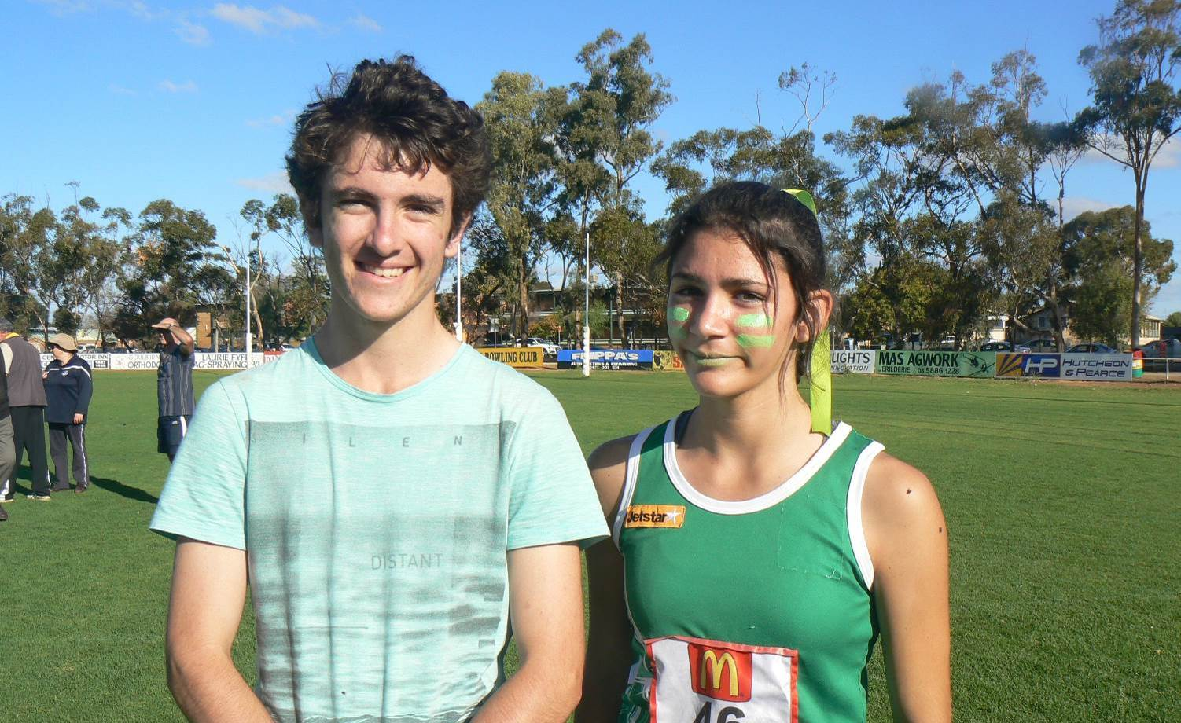

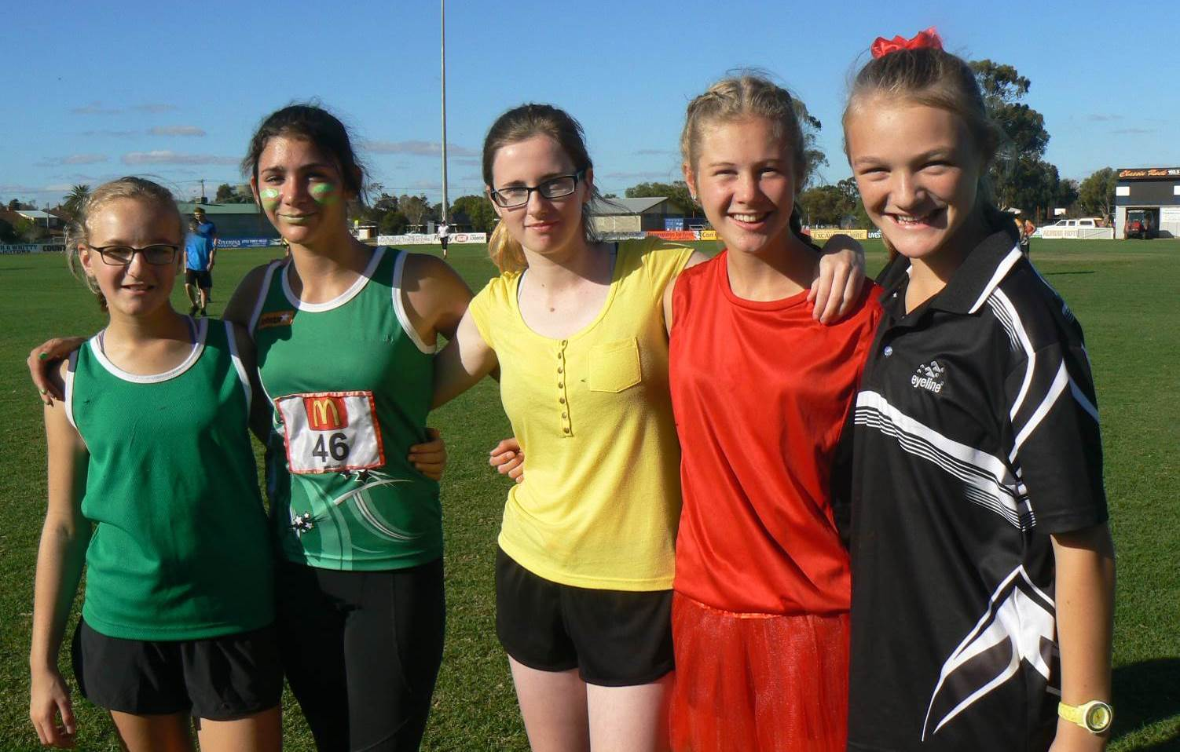Above: The fastest girls: Ally Barlow, Kayla Smith, Sabrina Taylor, Tiarna Burke and Jemma Coombs.
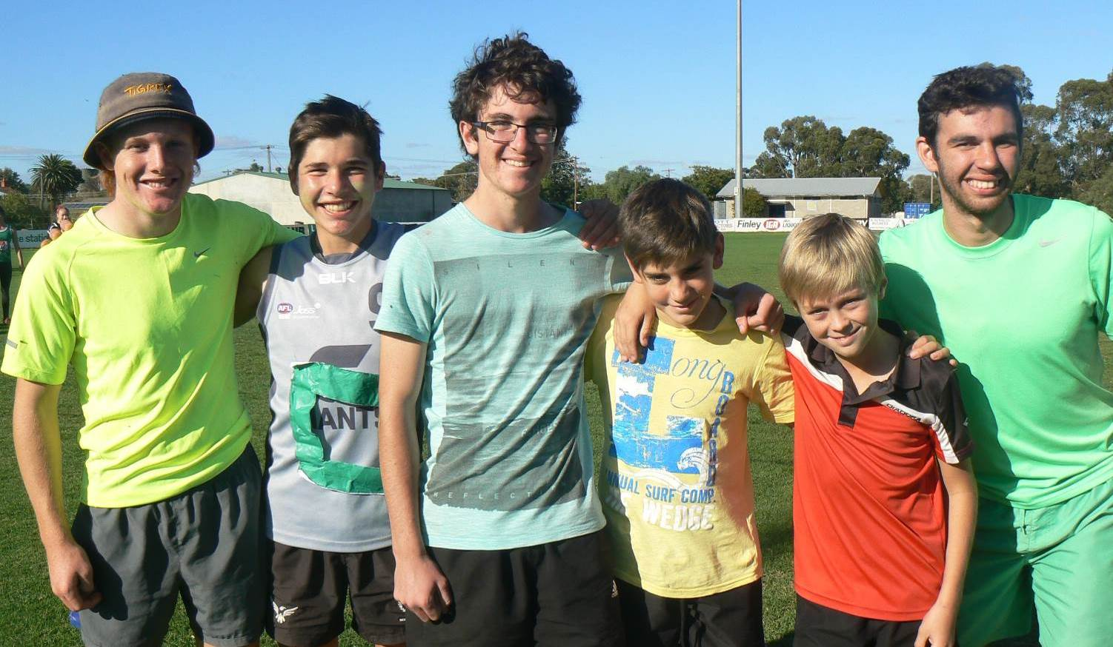Above: The fastest boys: Tyrone Smithers, Ben Ashley-Cooper, Nicholas Baldwin, Zander Nash, Cooper Burke and Samuel Orro

Overall age champions were:
 | Boys  1st | 2nd | Girls  1st | 2nd
12 Years | Zander Nash | Ben Chesworth | Jemma Coombs | Lily Kernaghan
13 Years | Cooper Burke | Will Sexton | Sascha Jones | Ally Barlow
14 Years | Ben Ashley-Cooper | Allan Gardiner | Hayley Doohan | Kayla Smith
15 Years | Dylan Maxwell | Tyrone Smithers | Tiarna Burke | Kattarina White
16 Years | Ben Fox | Nicholas Baldwin | Eloise Ashley-Cooper | Piper Hicks
17 Years | Storm Scott | Sam Orro | Kiara Keating | Li’i Vitale

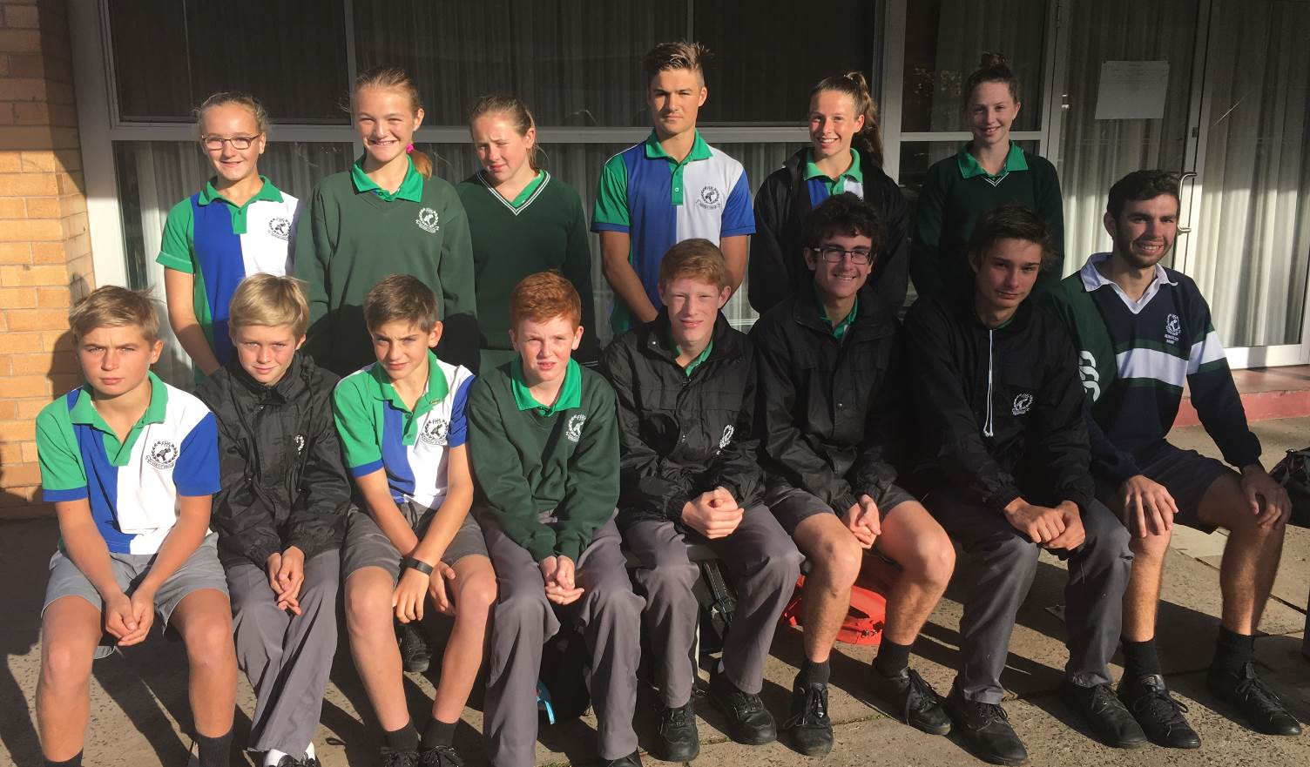
Above: Age Champions: (Back L – R) Ally Barlow, Jemma Coombs, Lily Kernaghan, Ben Fox, Eloise Ashley-Cooper, Piper Hicks. Front: Will Sexton, Cooper Burke, Zander Nash, Ben Chesworth, Allan Gardiner, Nicholas Baldwin, Storm Scott, Samuel Orro. Age Champions absent from photo are Ben Ashley-Cooper, Dylan Maxwell, Tyrone Smithers, Sascha Jones, Hayley Doohan, Kayla Smith, Tiarna Burke, Kattarina White, Kiara Keating and Li’i Vitale.

The winning house was Coree.
Well done all student who attended the carnival.

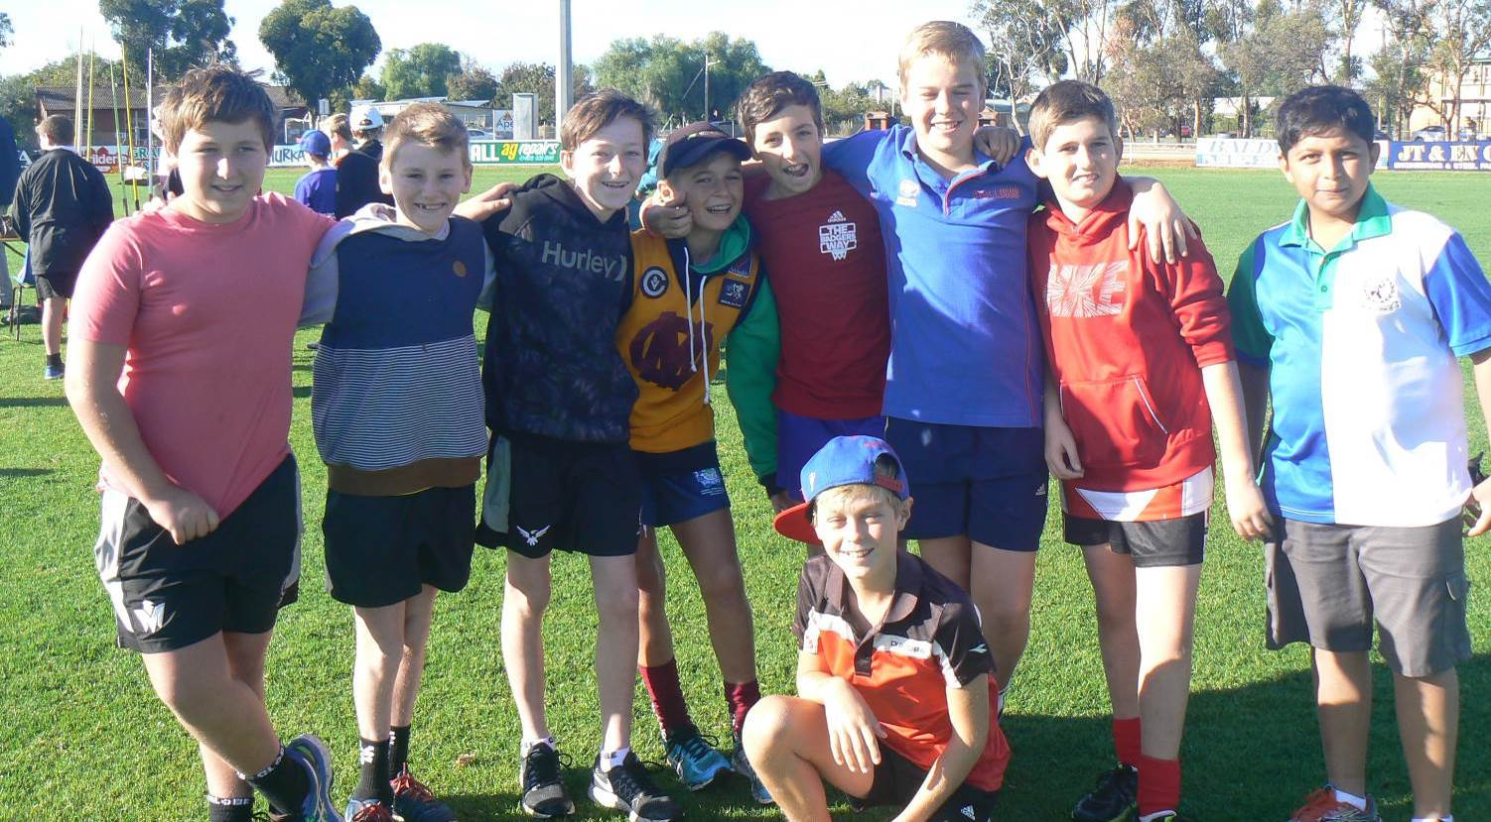
Above: Alex A’Vard, Jesse Modderkolk, Aiden Fennell, Will Sexton, Oliver Knight, Rory Knight, Max Cameron, Rishi Manikarao and Cooper Burke (front)
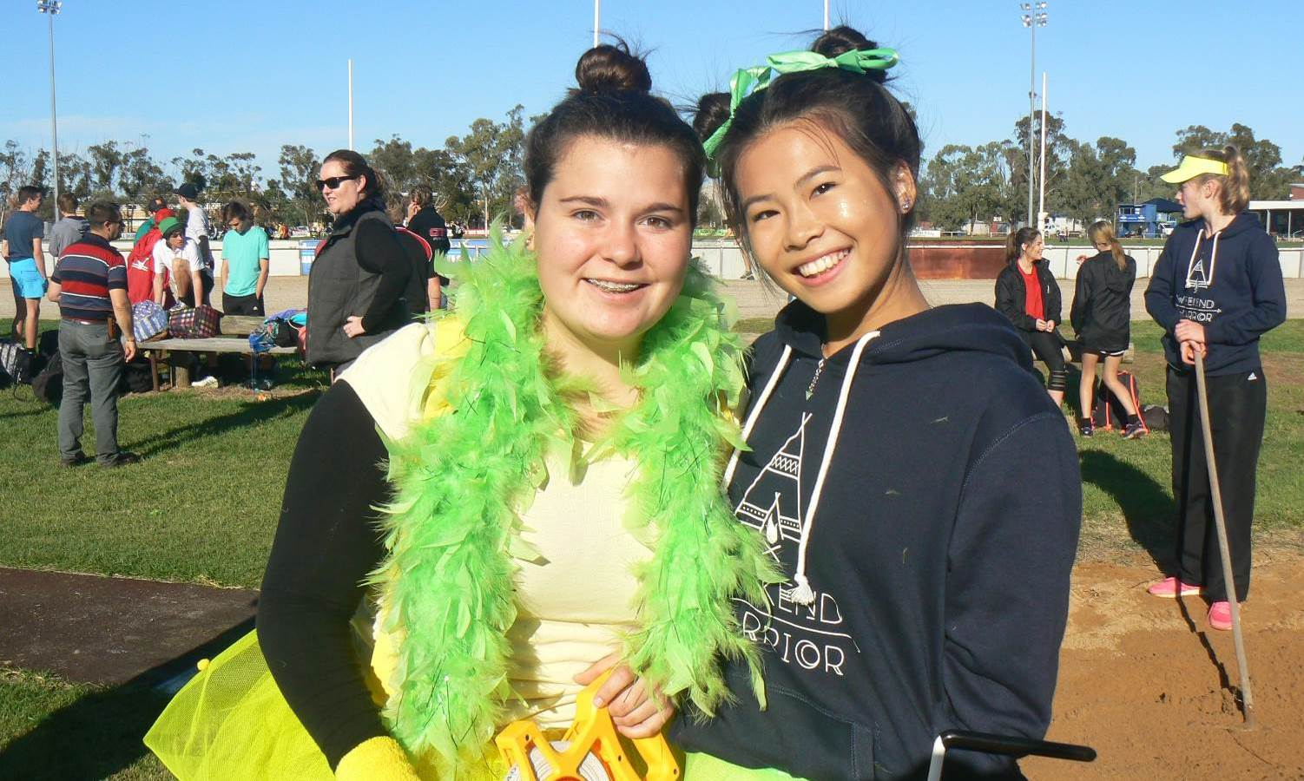
Above: Stephanie Wright and Mandy Huang.
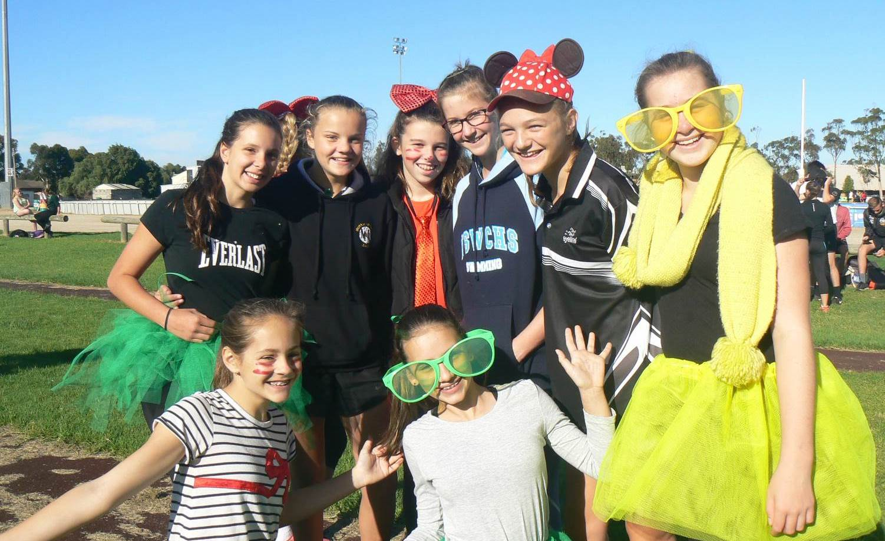Above Back L-R: Olivia Haynes, Lily Sharp, Annabel Middleton, Sascha Jones, Jemma Coombs, Isabel Alexander
Front L – R: Jasmine Ackers and Abbey Marshall
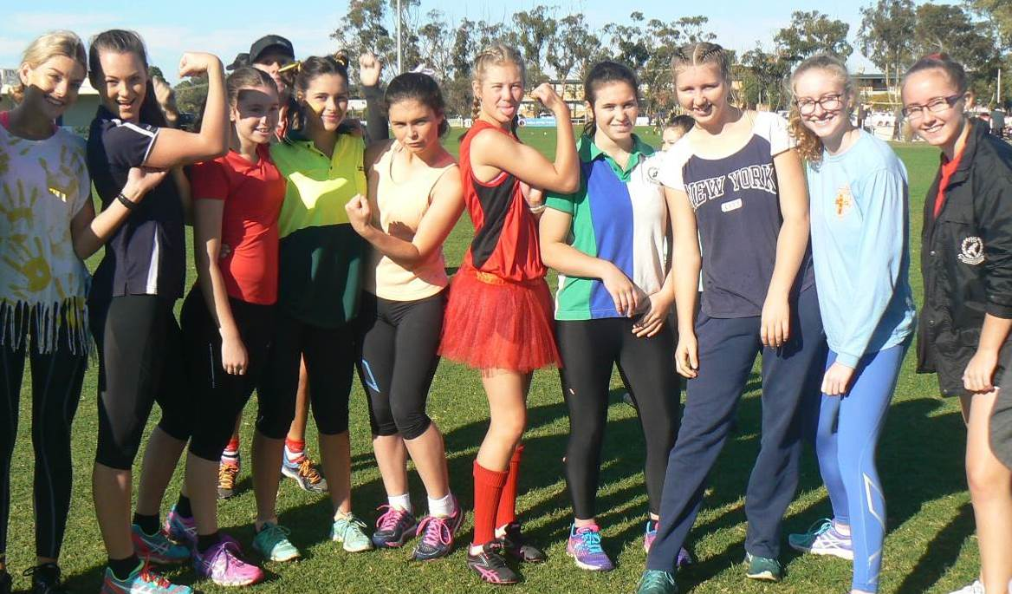
Above (L-R): Keeley Coates, Abbey Maconachie, Sharni Sykes, Holly Robinson, Dora Miaoudis, Tiarna Burke, Emily Gastin, Wynta Brain, Ellie Jones and Mikayla Ackers.
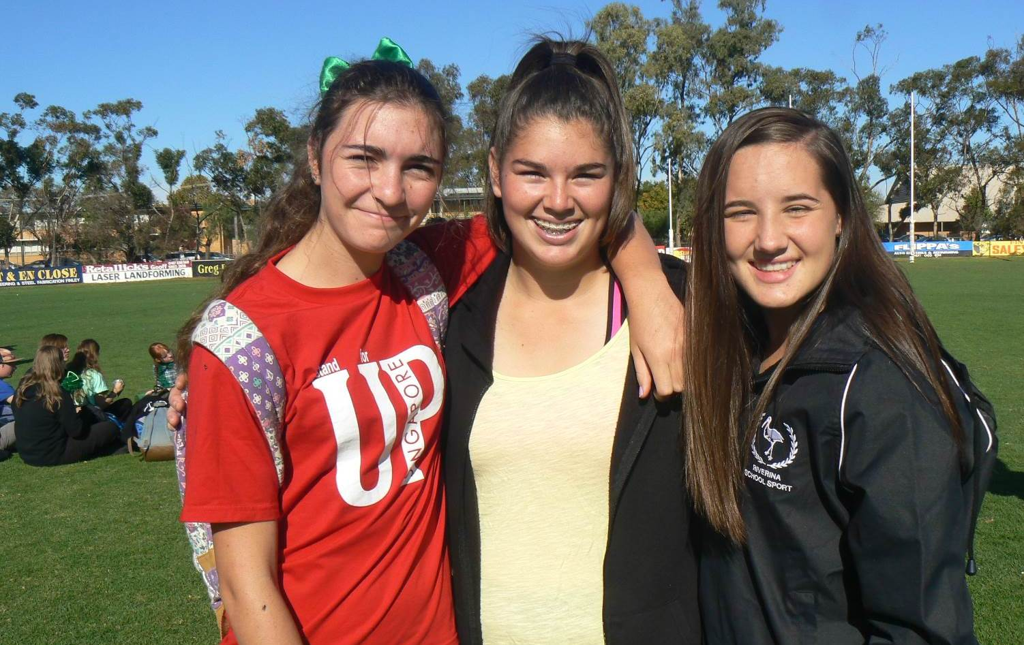Above L – R: Jade O’Bryan, Ally Barry and Kiara Keating.
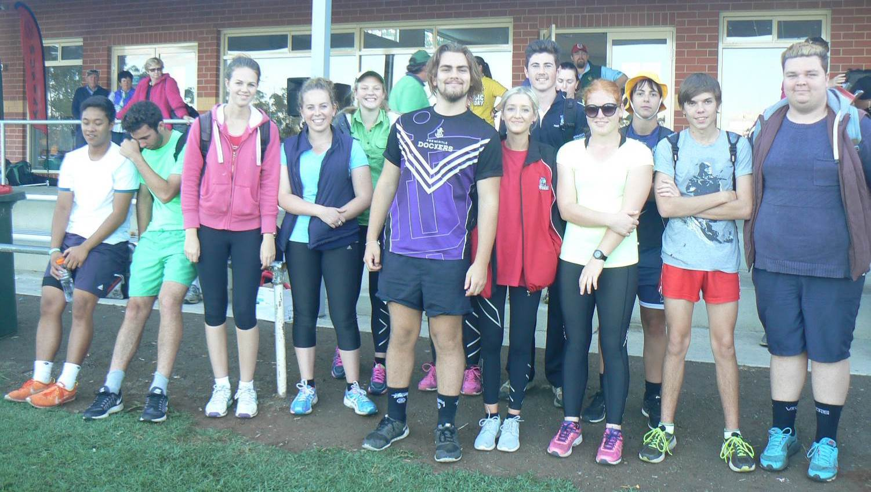Above: House Captains and Vice Captains: (L-R) Lanz De Peralta, Samuel Orro, Abbey Taylor, Alysha Knight, Zoe Stephens, Cameron Bowdern, Charlee Webster, Callum Robertson, Leah Dalgliesh, Jorja Daniel, Michael Percy and Tyson Peters.
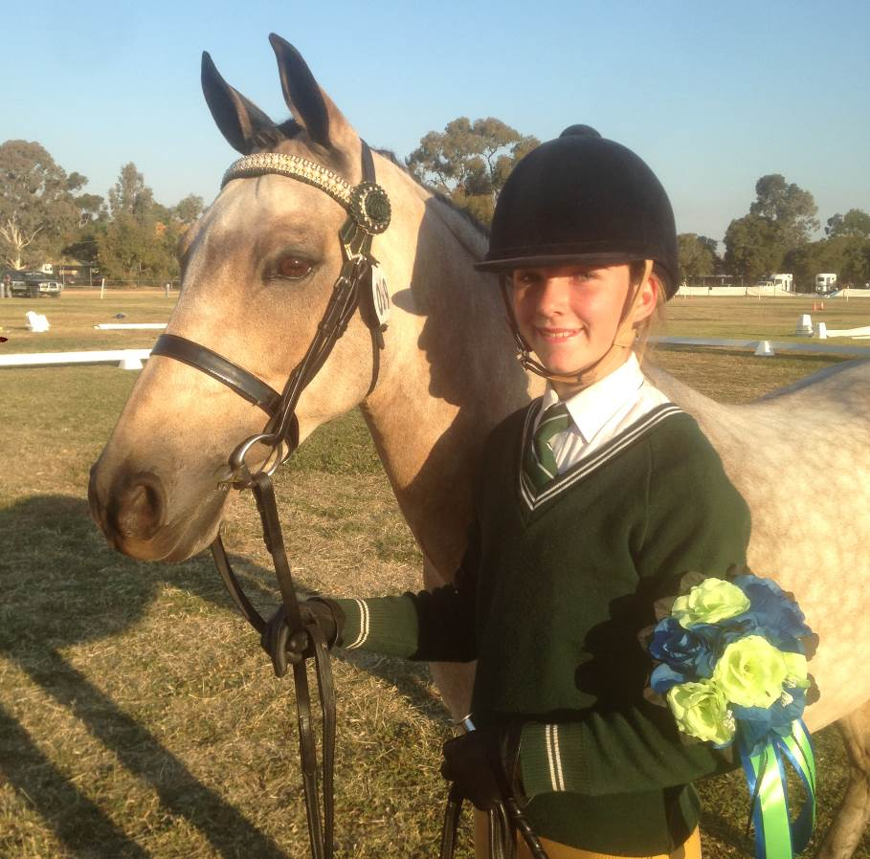
Equestrian Interschool
During the holidays four of our students, Georgia Lunn, Meg Marsden, Emma Marsden and Kate Eddy competed in the North Eastern Interschool Equestrian Team Challenge in Tatura. Schools enter teams of four and compete against other schools. Often composite teams of students from different schools are created when there are not enough students from one school to create a full team.
The girls competed in a range of areas including dressage, show jumping, games, musical ride and showing. All rode very well in each area.
Over all the team placed 15th out of a very competitive field of 31 teams.
Above: Georgia Lunn with her horse, Paris.

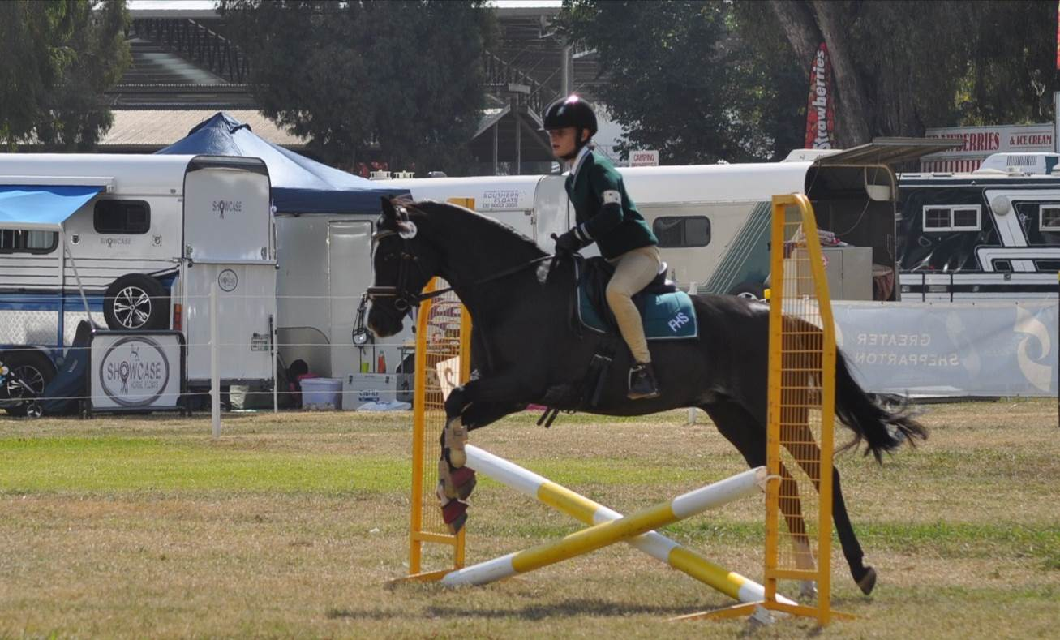
Above: Meg Marsden competing in the show jumping on her horse ‘Dakki’.
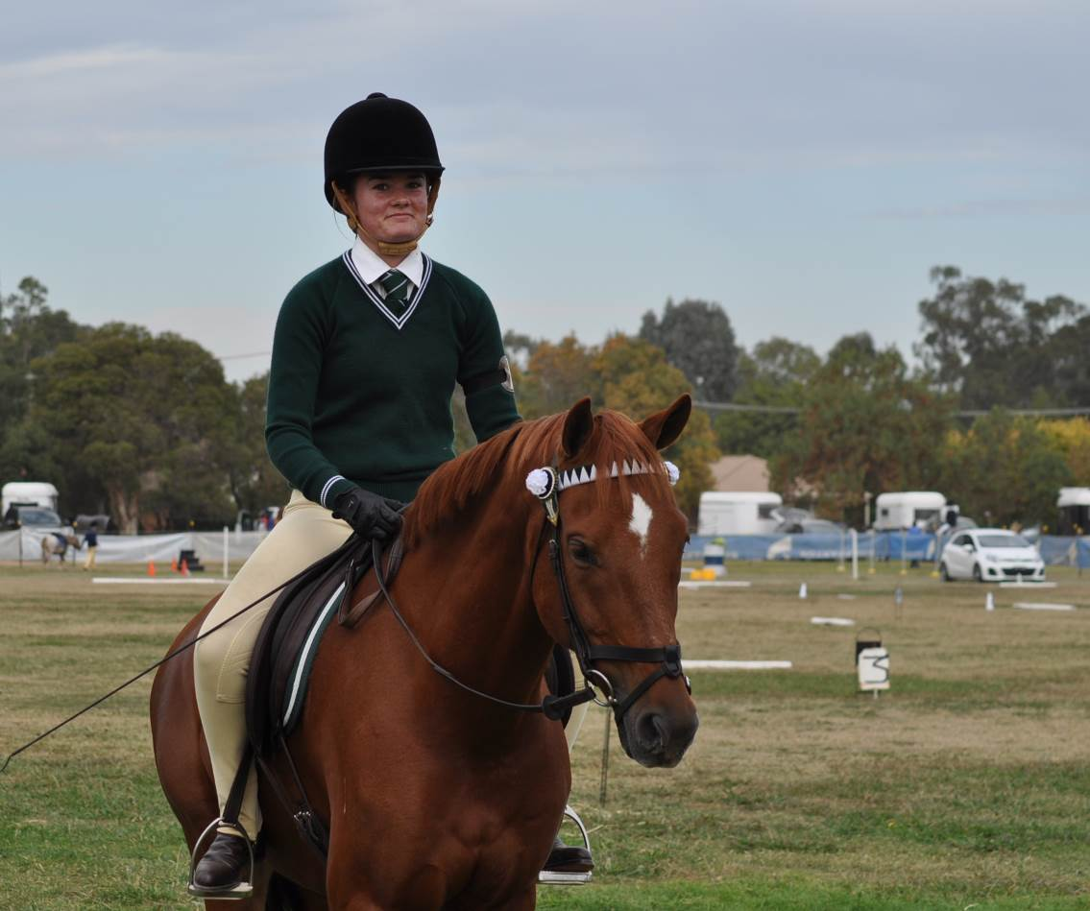
Left: Emma Marsden on her horse ‘Mr Ed’

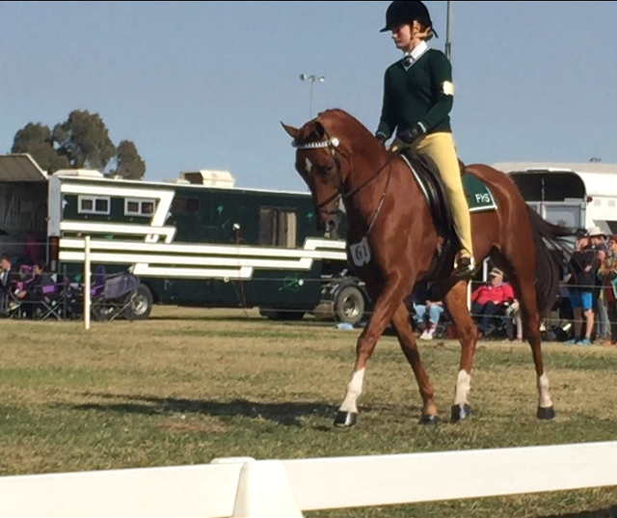

Right: Emma competing in dressage.
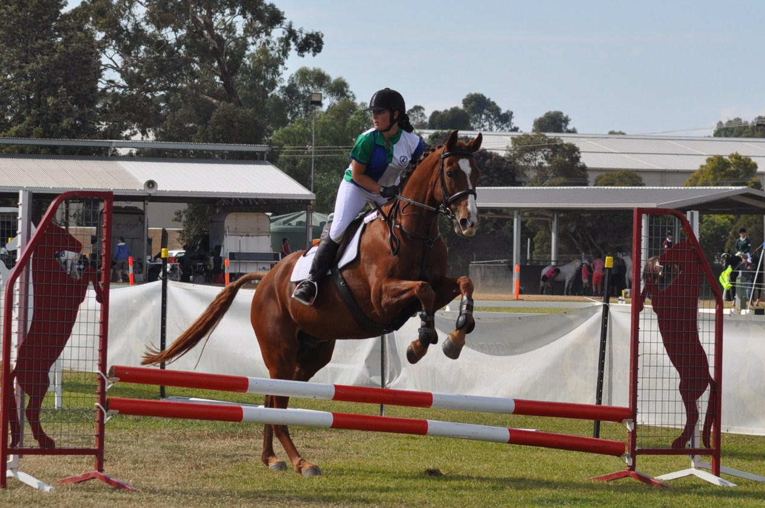
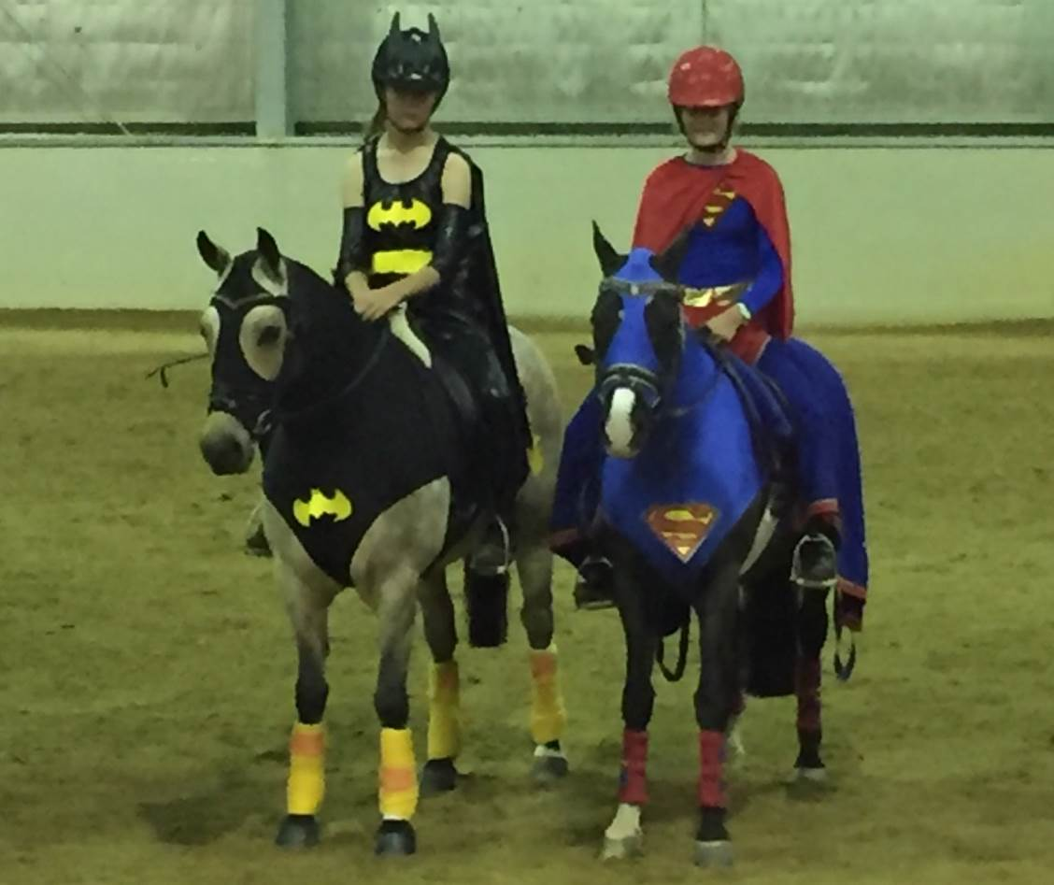
Above: Kate Eddy competing in showjumping on her horse ‘Rio’.

Right: Georgia and Meg dressed up for the Musical Ride. They placed 3rd in the secondary section of the event.

MADDD Night!
Last Wednesday the 11th of May, students performed in our annual MADDD night. MADDD night is a showcase for students to show the school and family members their special talents. They do this by means of Music, Art, Dance, Drama or Design. Students worked for many months, individually or in groups for the acts they were to perform, which was a brilliant show of their creative skills. With 260 tickets sold, guests thoroughly enjoyed the night, and students put on fantastic performances.
The theme for this year’s show was ‘Time’; students were required to base their acts on a certain time period. We had various acts from the 70’s and 80’s and one going further back into the 1930’s. Along with various acts based in more modern times and years that are yet to come. Our MC’s of the night were Jorja Daniel, Rosie Archer and Cherie Kantarias (pictured below). To correspond with the ‘Time’ theme the MC’s dressed as famous time travellers, Jorja being the 11th Doctor from Doctor Who, Rosie dressed as Marty McFly and Cherie was Doc Brown from Back to the Future.
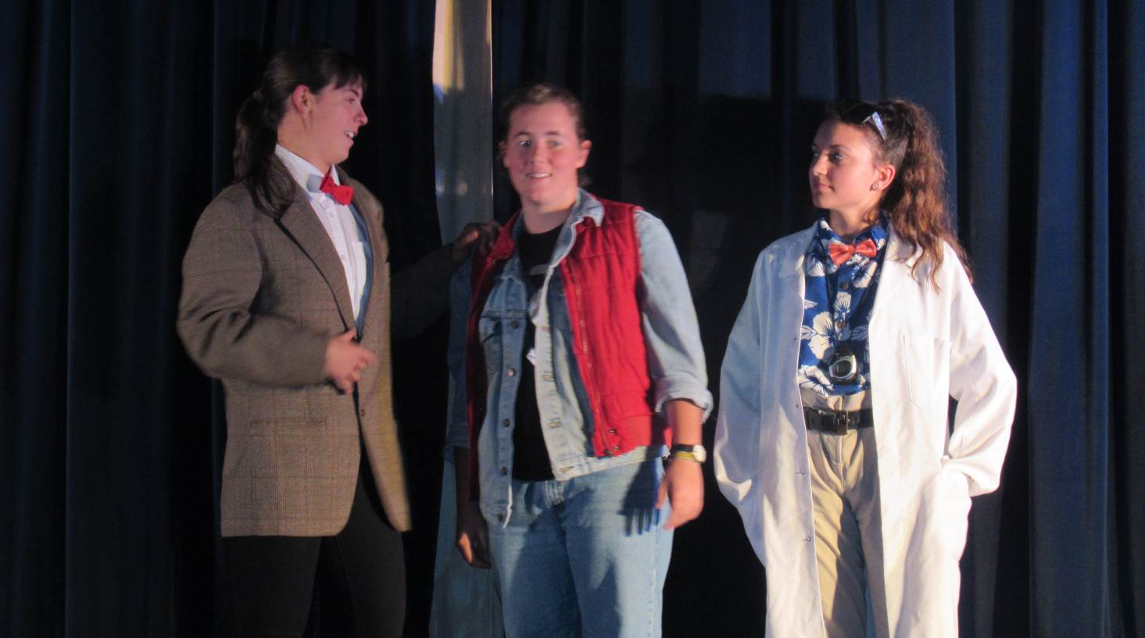
The Great Emu War- based on a true story in 1932 spun into a funny skit along with a glorious dance battle at the end which had the audience laughing hysterically. Students involved with this performance were: Stephanie Harris, Ann Cameron, Grace Turley, Skye Thompson, Brooklyn, Sabrina Taylor, James Mortlock, Jessica Sutton, Sheridan Mortlock and Kaitlynn Jones.
Grease Mega Mix - many students danced to a mash up of various popular grease songs, with two main dancers being Danny (Makayla Balden) and Sandy (Kiarni Jones). Other students from mixed year groups all came together to make this dance happen.
Stolen Dance - Bella Jackson sang this song by Milky Chance. She wore very bright, colourful clothes in a hippie style and sang beautifully.
Carousel Cry Baby- was a contemporary, mechanical dance meant to look like dolls being controlled by invisible strings.
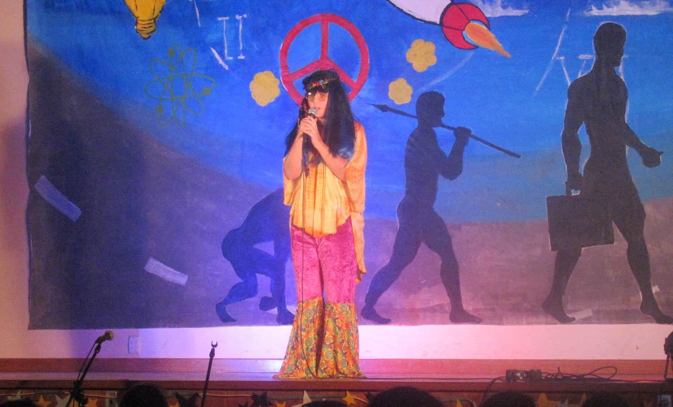
Above: Bella Jackson singing ‘Stolen Dance’.
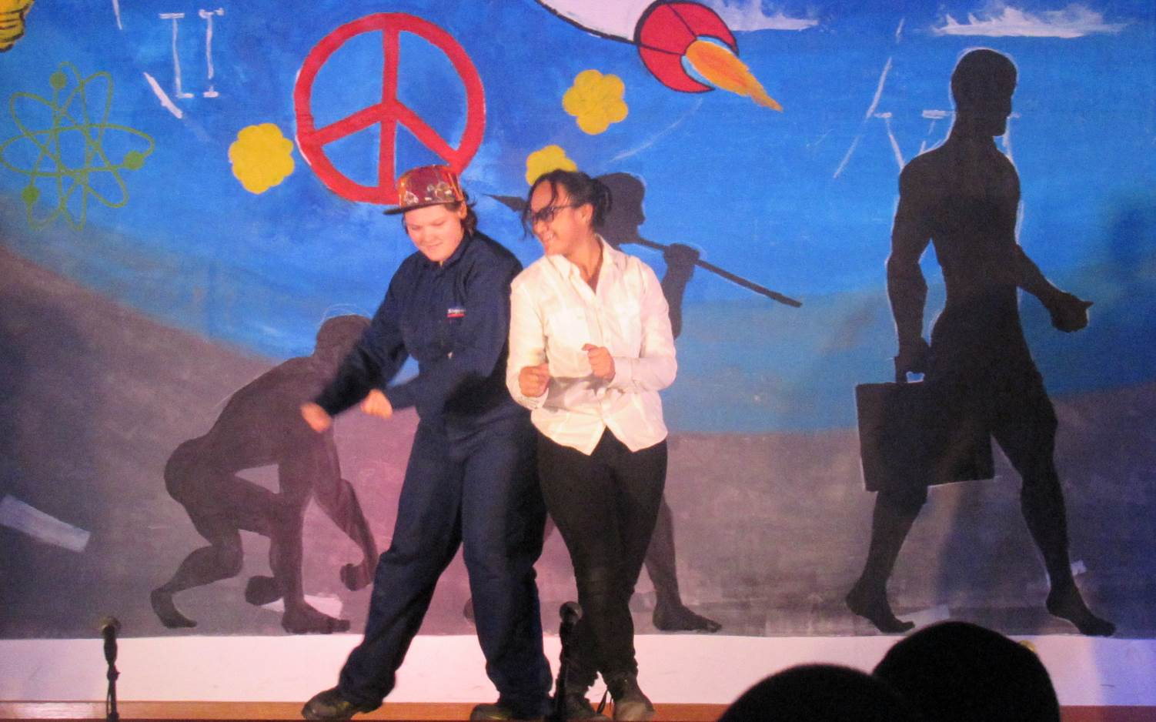
Below: Natalie Pitt and Li’i Vitale.

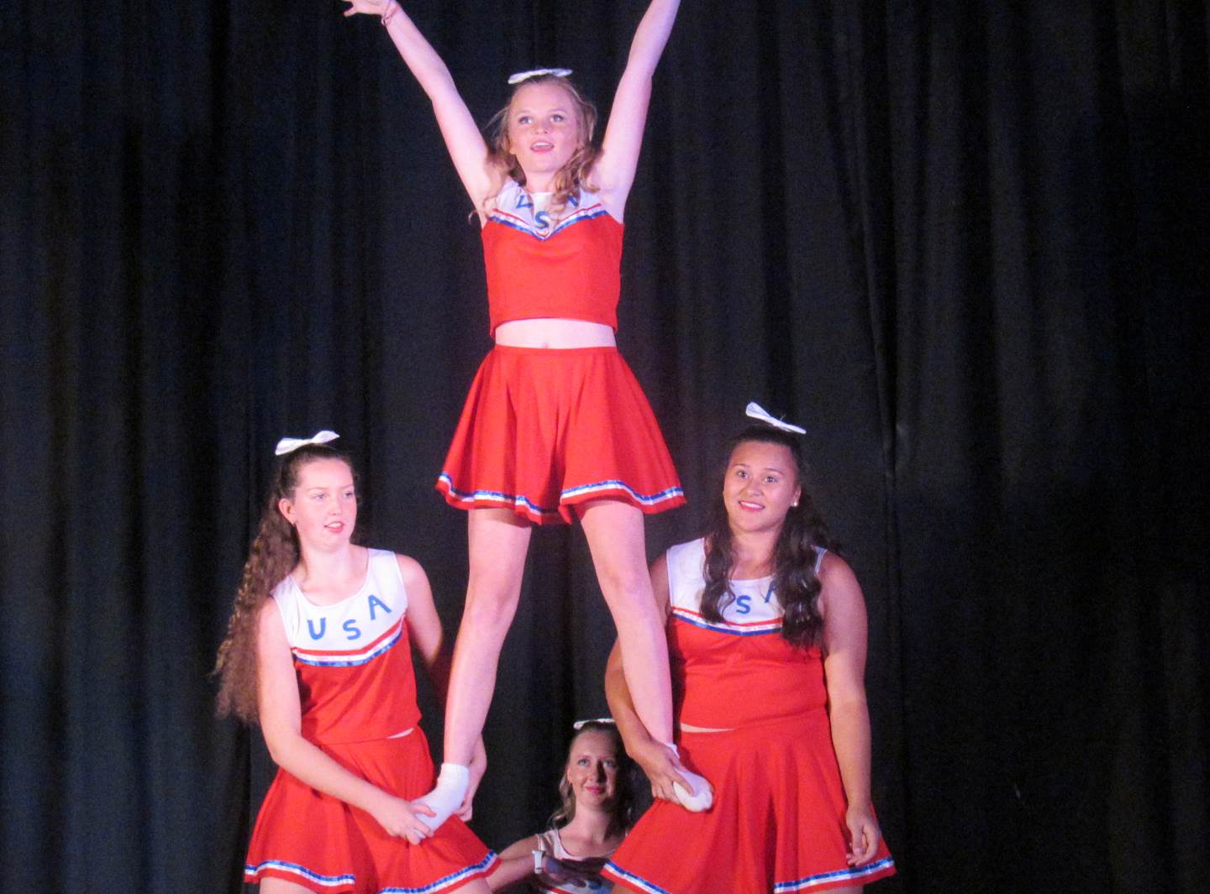
Above: Michelle Barnes, Hannah Heaney, Mikayla Condon and Jessica Adams dancing to ‘Hey Mickey’.
Below: Georgia Webb and Jessica Sutton singing ‘Mama Mia’.
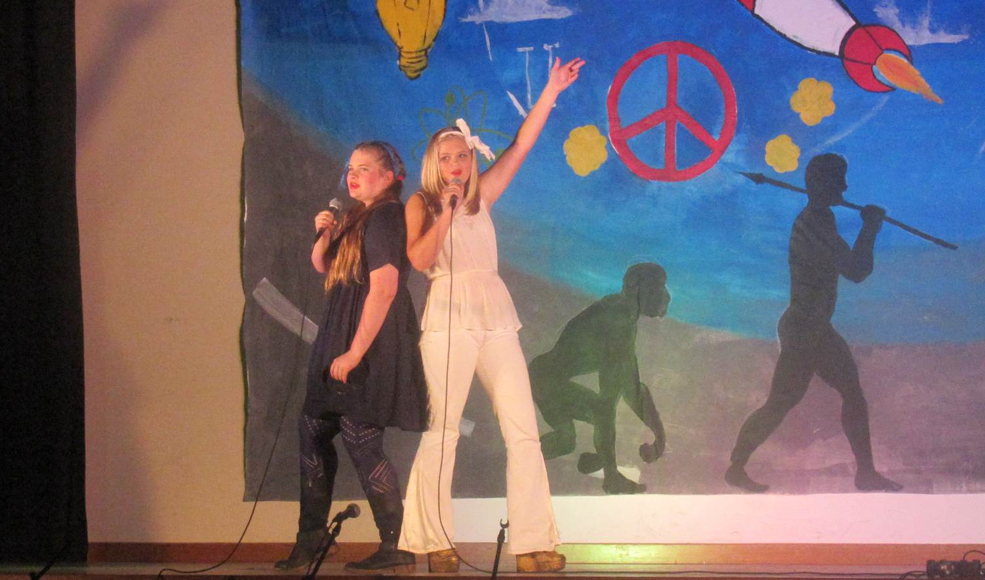
All the students involved whether it was performing or backstage did exceptionally well and the night went smoothly thanks to the stage manager, Connor Smith, and the staff involved. The audience enjoyed supper provided by the Hospitality, Food Tech staff and students. The back drop was designed and painted by a team directed by Art teacher Mr Kieran Davis. A special thanks goes to the following people for all their help in the tasks leading up to the night; Brian O’Hora, Gerard Tessier and Mrs Nicole Close. A big thanks to the MADDD staff team and also for the parents who baked for the night. The list just goes on with the amount of people that make the night what it is. We can’t thank them enough!
We look forward to next year!!!
Media Hub Team

Finley High School P&C

HELPERS NEEDED
The Finley High School P&C are catering for the FADAMS production.
This is our MAJOR fundraiser for the year.

The dates are Friday 3rd and 17th June and Saturday 4th and 18th June.
The times are: 5pm at School, 6:30pm at School of Arts Hall.
It would be greatly appreciated if any parents can help to prepare, serve or wash dishes on any of these nights.

Please phone or text Suzanne Robertson on 0417405107 or 0358859229.

CANTEEN ROSTER
Canteen Contact and Number
Mrs Kaylene Dawe 5883 1105
….LADIES, Please note 10am start….
May
20 D Thomas, L Bryce
23 J Russell, J Orro
24 P Neeseen, R Lockhart
25 G Ferguson
26 T Roe
27 J Congdon, J Burdon
30 D Pyke, S Congram
31 S Robinson
June
1 L Knight
2 S Robertson

Community Announcements
Open Day at Finley Fire Station

Finley Fire Station will be open from 10am to 2pm on Saturday 21st May. Families are encouraged to come along and meet their local fire fighters and learn more about fire prevention.

A range of free activities will be on offer, including fire fighting demonstrations, station tours and fire safety presentations. Fire fighters will also be able to provide advice on installing smoke alarms, changing smoke alarm batteries and preparing a home fire escape plan.

Children will be able to see fire engines and fire fighting equipment up close, which is always one of the highlights of this much-anticipated day. For the first time, FRNSW is this year partnering with LEGO City to spread the fire safety message on Fire Station Open Day. The partnership will see a new Brigade Kids activity booklet and LEGO City mini figures available for Open Day Visitors.

Station Commander John Hand said: “With May being the 10th anniversary of the introduction of smoke alarm legislation, Open Day is a timely opportunity to talk to the experts about replacing your smoke alarms”.

“Given that not all smoke alarms last beyond 10 years, this year we’re encouraging residents to replace their out dated alarms with the latest photoelectric smoke alarms, which provide earlier detection and fewer false alarms”.

“Why not come along to Finley Fire Station on Open Day and come and talk to us about how you can reduce the risk of fire destroying your life,” Station Commander John Hand said.

Natalie Curr, Brand Manager for LEGO Australia said “LEGO City is based on everyday heroes such as fire fighters, allowing children to build and role play. This partnership with Fire and Rescue NSW is the perfect opportunity for LEGO City to support the real life heroes in our community.”



